MMPA Implementation and Data Management (Carretta)

**Marine Mammal Stock Assessments (SARS)** 1

R-Code related to SARS 4

**Human-Caused Mortality and Serious Injury (HCMSI)** 4

Annual HCMSI report 4

*SeriousInjury* R-Package 4

Drift Gillnet Bycatch Estimation 6

**Line Transect (DAS) Data, R-Code and related physical assets** 6

R-utilities related to cruise data. 7

**References** 7

# **Marine Mammal Stock Assessments (SARS)**

Locations: “C:\Carretta\Stock Assessment Reports (SARS)\Current SAR Word Files”

Also check for files in the Sar2024 and Sar2025 folders of the main SARS directory, as draft 2024 SARs were released for public comment in February of 2025, and draft 2025 SARS are being reviewed by the PSRG in April 2025. The Pacific Islands Science Center will have the most-recent versions of their reports, if you need to locate the latest version being prepared for SRG review and public comment. An overview of all Pacific SARS that show the current and proposed revision status is included in a Word doc titled “**SAR Summary Table 2025 Draft SARs.docx**” as of this writing in April 2025. It is also found in the ‘Current SAR Word Files’ folder.

The SAR editor should be familiar with the [Guidelines for Preparing Marine Mammal Stock Assessments (NMFS 2023)](https://www.fisheries.noaa.gov/national/marine-mammal-protection/guidelines-assessing-marine-mammal-stocks) and section 117 of the Marine Mammal Protection Act. Keeping up with the marine mammal literature is also critical. The editor is also responsible for drafting and coordinating responses to public comments on draft SARS.

The Pacific Region SARs are written by 4 separate laboratories: SWFSC, NWFSC (Southern Resident Killer Whale = Brad Hanson), AKFSC (several pinniped reports = Sharon Melin), and PIFSC (Amanda Bradford). The Pacific SAR editor coordinates the annual revision of reports, along with the Office of Protected Resources (OPR review of draft and final reports). Responsibility for archiving the most-recent versions of individual SAR files ultimately rests with the authors of the individual SARs, for example, PIFSC maintains its own files. The SAR editor should try to mirror all up-to-date SAR files in a single place though. If a Word file is lost or corrupted, a PDF to Word conversion ([using the online versions of published SARs](https://www.fisheries.noaa.gov/national/marine-mammal-protection/marine-mammal-stock-assessment-reports-species-stock)) is useful for reconstruction.

Prepare draft SARs each fall / winter in preparation for the winter / spring Pacific Scientific Review Group meeting. Draft SARs are submitted to the SRG liaison ([Laura.McCue@noaa.gov](mailto:Laura.McCue@noaa.gov) PIFSC) 6 weeks before the meeting, so that 1) OPR can have 3 weeks to review them for issues and 2) the SRG liaison can send them to the Pacific Scientific Review Group (PSRG) 3 weeks before the meeting. Post-meeting, draft SARs are further revised, based on comments received. By summer, draft SARs are usually published in the Federal Register for a 90-day public comment period.

The SAR annual cycle has taken a year to complete in recent years. For example, the 2024 draft SARs were just released for public comment in March 2025, during the same time that we were submitting draft 2025 SARs to the PSRG. This overlap makes the SAR editor task more difficult, as it means multiple ‘draft’ versions of the same SAR may exist at one time (*e.g*., there are currently two versions of the Southern Resident Killer Whale SAR (draft 2024 in public comment and draft 2025 submitted for PSRG review). Ideally, the final 2024 version should have been published prior to drafting a 2025 report. This necessitates accepting changes to the draft 2024 version to use as a template for the 2025 report, not a good situation.

A variety of techniques are being used to revise the reports annually, from the simplest (Word markup and track changes, SWFSC), to more complex R-based revision, using Quarto or Markdown (MML, PIFSC). Common to all approaches is the requirement to show transparent revisions for the regional Scientific Review Groups and the public to assess. Some examples of how actual revisions should appear are shown in Figure 1.

List of current SAR personnel and roles as of 30 April 2025

[Jim.Carretta@noaa.gov](mailto:Jim.Carretta@noaa.gov) (Writes, edits, coordinates the production of SARs from multiple Science Centers. Sometimes responsible for ensuring that final SARs are 508 compliant for posting on websites. Otherwise, someone in the publications division (formerly [Kit.Johnston@noaa.gov](mailto:Kit.Johnston@noaa.gov), retired) who deals with Technical Memoranda should help with this. Compliant documents need to be sent to the [NOAA Institutional Repository](https://docs.google.com/forms/d/e/1FAIpQLSc7_zwKEJ4ANWsvnlJR1S-Bu2C2zhPGzoh2j6oNuNSbUtTe-Q/viewform?pli=1) to be checked prior to publication.

[Eric.Patterson@noaa.gov](mailto:Eric.Patterson@noaa.gov), [Kristy.Long@noaa.gov](mailto:Kristy.Long@noaa.gov), [Megan.Wallen@noaa.gov](mailto:Megan.Wallen@noaa.gov) (National review of draft and final SARs prior to release for SRG review / public comment, and final publication). [Zachary.Schackner@noaa.gov](mailto:Zachary.Schackner@noaa.gov) (Federal Register coordination and review of SARs for release as drafts and 90-day public comment period). [Laura.McCue@noaa.gov](mailto:Laura.McCue@noaa.gov) (Pacific SRG liaison. Draft SARs sent to her at least 3 weeks before an SRG meeting for distribution to the group.) [Justin.Greenman@noaa.gov](mailto:Justin.Greenman@noaa.gov), [Lauren.Saez@noaa.gov](mailto:Lauren.Saez@noaa.gov) : they provide annual information on the human-caused mortality and serious injury cases that feed into the SAR revision process.

One example of how revisions should appear: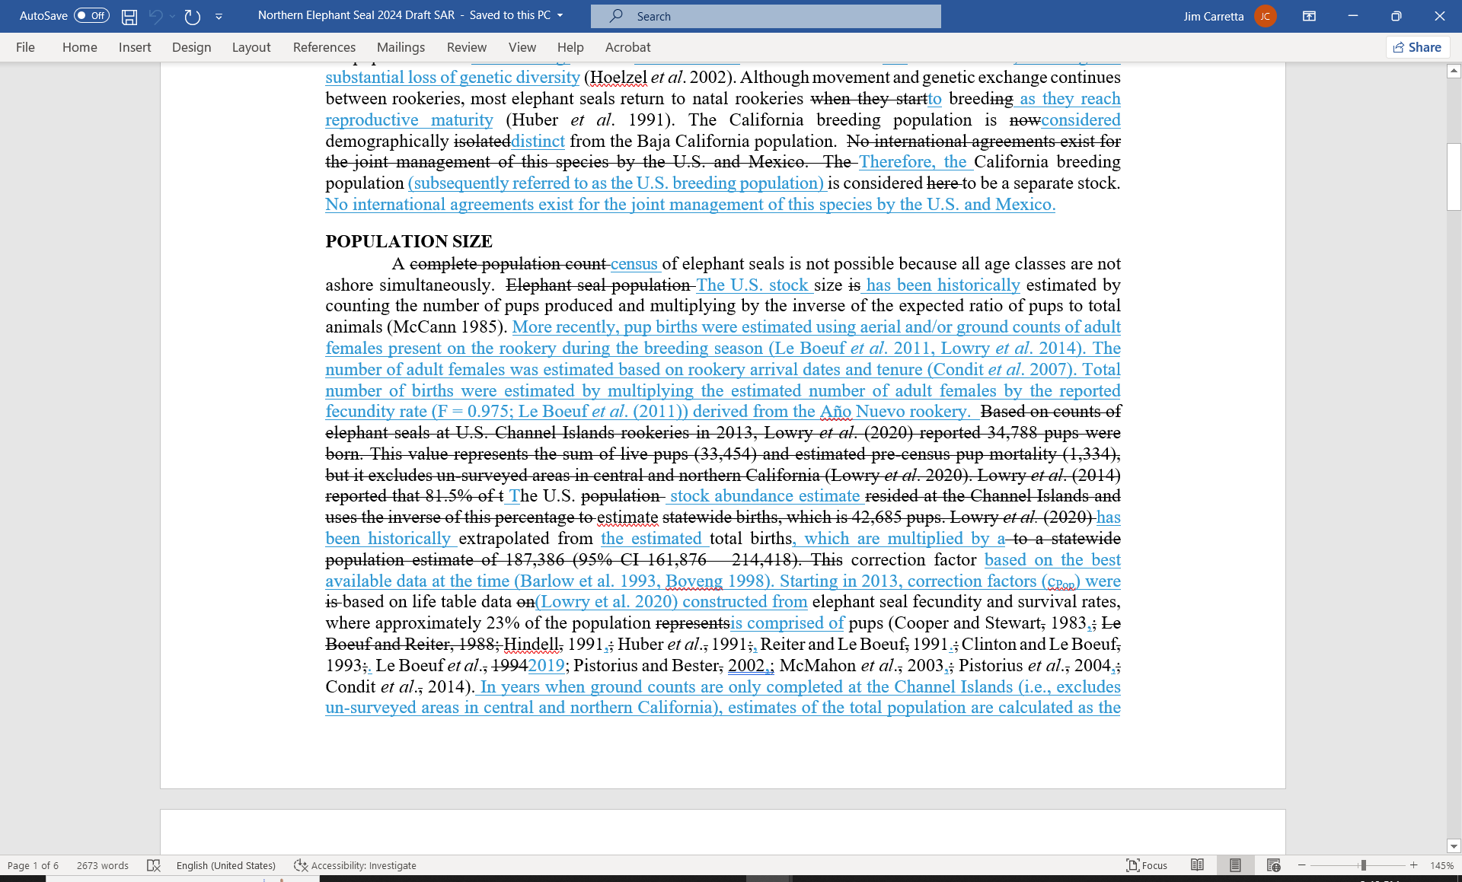

The Appendix in the SARs dealing with Fishery Descriptions has largely fallen by the wayside due to lack of bandwidth. Future editors would want to coordinate with the various regional offices for updates, especially whoever works on the NMFS List of Fisheries ([Dan.Lawson@noaa.gov](mailto:Dan.Lawson@noaa.gov) West Coast Region).

## R-Code related to SARS

Plot sightings and effort maps directly from DAS data:

“C:/Carretta/Mapping/Plot DAS Effort and Sightings Data SAR version.R”

Code loops through all species codes and generates JPEG maps of on-effort segments and on + off-effort sightings. Naming convention uses numeric species codes for cetaceans, *e.g*. “044 Plot.JPG” = Dall’s Porpoise. There is also a Github package (‘[CruzPlot](https://github.com/SWFSC/CruzPlot)’) that can be used to produce low-resolution plots of DAS effort and sightings.

Prorate unidentified whale entanglements and vessel strikes to species: “Carretta/Github/Prorate_Unid_Whale_Entanglements/Prorate_Unid_Whale_Entanglements.R” (Carretta 2018)

Unidentified large whale entanglements are prorated to species, using a simple randomForest model. Used in tabulating human-caused mortality and serious injury for large whale SARs.

# **Human-Caused Mortality and Serious Injury (HCMSI)**

Location: “C:/Carretta/Github/HCM_SI”

## Annual HCMSI report

Annually, accounting for HCMSI is required to 1) produce an annual HCMSI Technical Memorandum and 2) update SARS. The annual HCMSI is produced in the format of Carretta *et al*. (2024), based on R-Markdown code (“CARRETTA/Github/HCM_SI/HCM_SI_Report.RMD”) and the R-Script ‘SeriousInjuryExtract.R’. This is located in the “CARRETTA/Github/HCM_SI” folder = R-Studio Project (*not a package*). The annual report is based on data-mining an Excel file (“Anthropogenic_Mortality_Serious_Injury_Carretta.xls”) that is updated annually. The annual HCMSI report includes the most-recent 5 years of data to inform SARS.

Many contacts exist for acquiring HCMSI data that inform Pacific SARS, including individual states ([CA sea lion removals](https://www.fisheries.noaa.gov/west-coast/marine-mammal-protection/marine-mammal-protection-act-section-120-pinniped-removal) under Sec. 120 of the MMPA [robert.c.anderson@noaa.gov](mailto:robert.c.anderson@noaa.gov) ), regional offices (AK, WCR), with a roster including [Justin.Greenman@noaa.gov](mailto:Justin.Greenman@noaa.gov), [Lauren.Saez@noaa.gov](mailto:Lauren.Saez@noaa.gov), [Nancy.Young@noaa.gov](mailto:Nancy.Young@noaa.gov), [Amelia.Brower@noaa.gov](mailto:Amelia.Brower@noaa.gov), [Amanda.Bradford@noaa.gov](mailto:Amanda.Bradford@noaa.gov), [Kayleigh.Somers@noaa.gov](mailto:Kayleigh.Somers@noaa.gov) .

## *SeriousInjury* R-Package

Locations: “C:\Carretta\Github\SeriousInjury” and repositories listed below

A Shiny Tool and R-Package used to assess the probability of death for large whale injuries. It is under consideration for use as a NMFS National Policy for assessing large whale injuries. Based on the Carretta and Henry (2022) publication. Two identical Github repositories exist for the *SeriousInjury* package:

<https://github.com/SWFSC/SeriousInjury>

<https://github.com/JimCarretta/SeriousInjury>

The *SeriousInjury* package can be installed in R as follows:

# make sure you have devtools installed

if (!require('devtools')) install.packages('devtools')

# install from GitHub

devtools::install_github('SWFSC/SeriousInjury')

# if this install fails, use this alternative method, using package 'pak':

pak::pkg_install("SWFSC/SeriousInjury")

library(SeriousInjury)

# see SeriousInjuryTutorial() for a guide to the package

Once installed, the function *SeriousInjuryTutorial*( ) opens an HTML window as shown in Figure 2.

Figure 2. *SeriousInjury* Tutorial screen grab

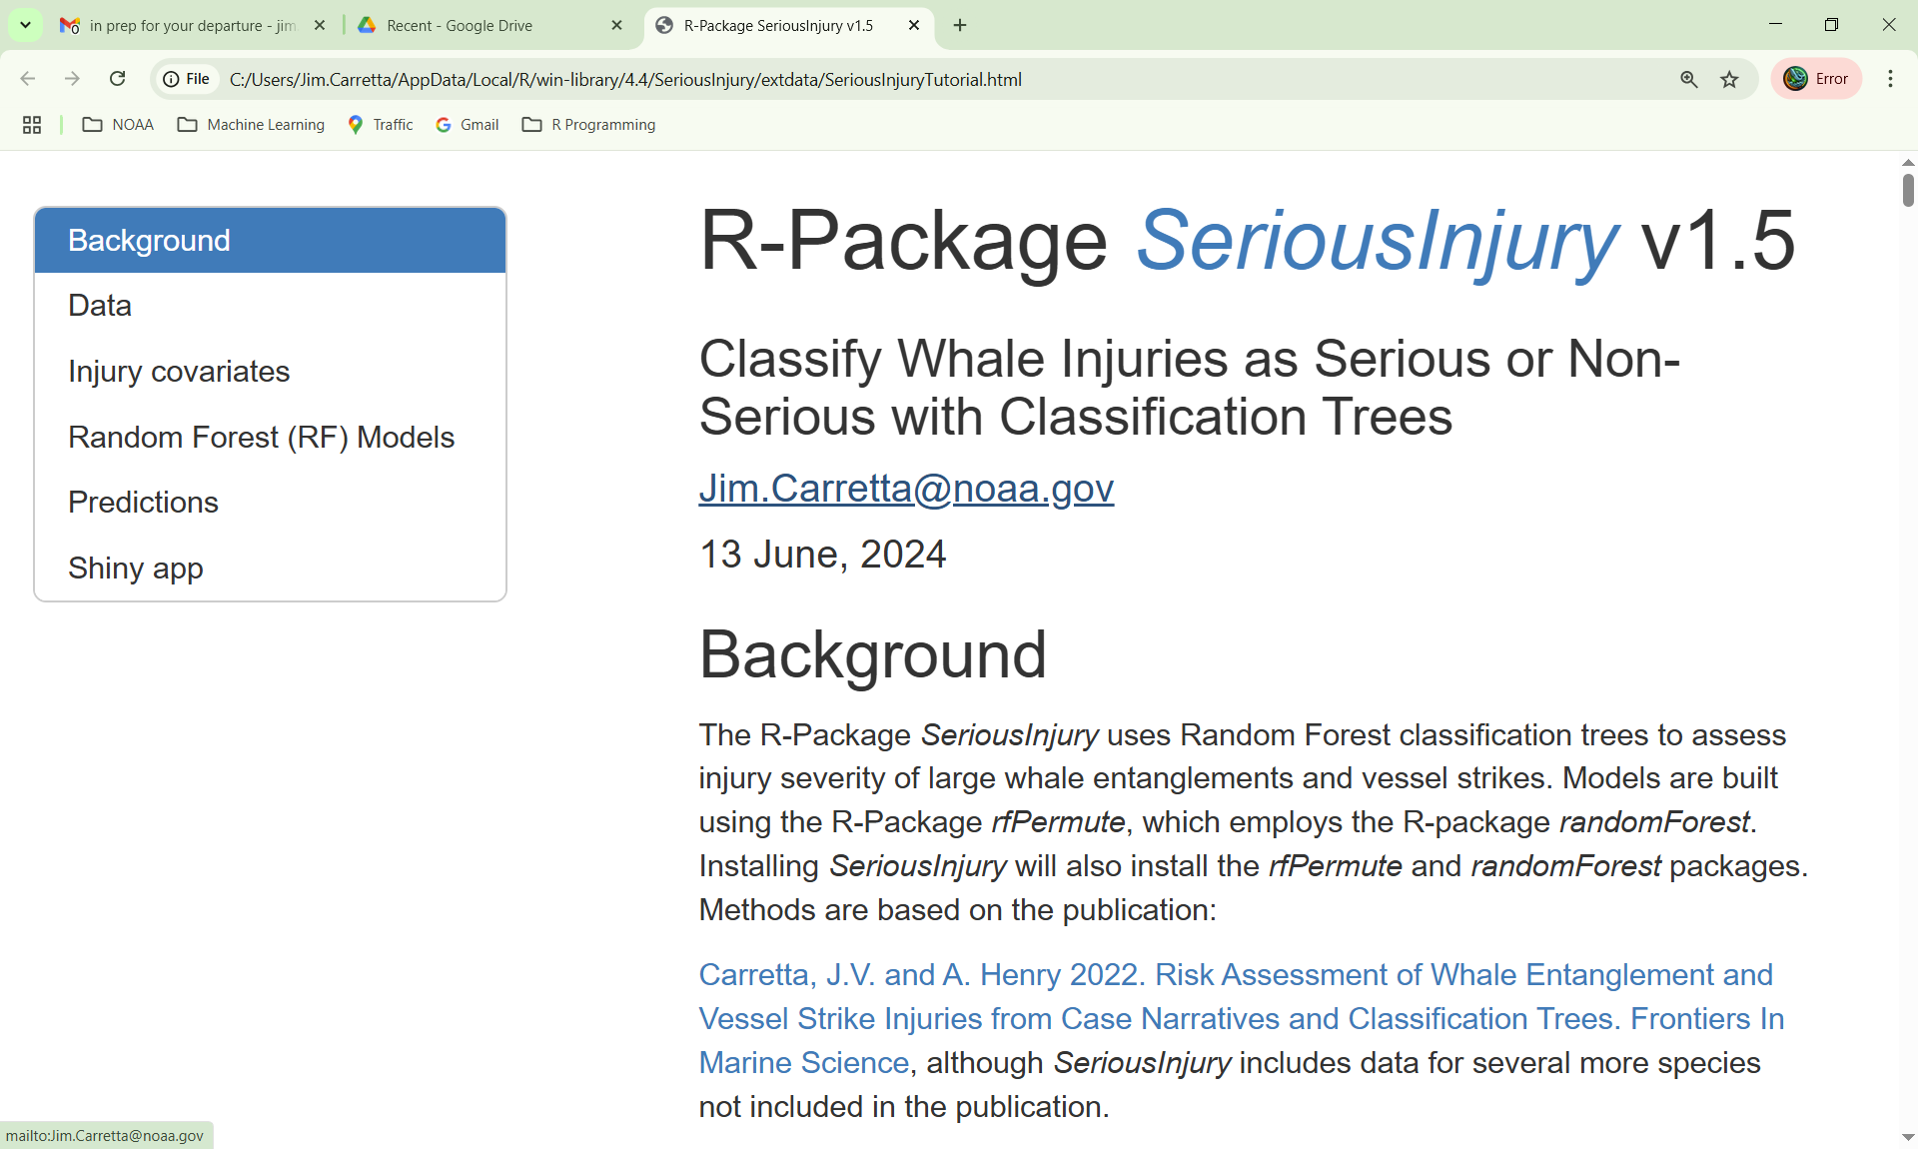

## Drift Gillnet Bycatch Estimation

This fishery is scheduled for phase-out in 2027, stay tuned. Only a handful of vessels participating. Data is housed at [PacFin](https://reports.psmfc.org/pacfin/f?p=501:1000) and requires a login and a data confidentiality agreement. The files used for data manipulation and analysis are in the directory “C:/CARRETTA/Github/DGNBycatch” (R-Studio project, *not a package*). The entire workflow including data download, variable selection, and bycatch estimation is found in the HTML file:

“C:/Carretta/GitHub/DGNBycatch/R/DGN_Bycatch_Workflow.html”,

Which is generated via “C:/Carretta/GitHub/DGNBycatch/R/DGN_Bycatch_Workflow.RMD”

People to know: [charles.villafana@noaa.gov](mailto:charles.villafana@noaa.gov) (Observer program). He knows all the PacFin folks housing the data, including: Ryann Turcotte [RTurcotte@psmfc.org](mailto:RTurcotte@psmfc.org) , and Robert Ryznar [RRyznar@psmfc.org](mailto:RRyznar@psmfc.org)

# **Line Transect (DAS) Data, R-Code and related physical assets**

In addition to DAS data collected with WinCruz and Viscruz on our surveys, there are binders of sighting forms, observer green books, and microfiche located in Room 263 off the parking garage. We have maxed-out on space, so there is currently overflow from 2018 and 2024 cruises in Room 421 (Carretta). Additionally, we store microfiche data with Corovan offsite, the point of contact is Henry Salazar and email is [sdvault@corodata.com](mailto:sdvault@corodata.com) . There are a limited number of cruises that Al Jackson and others scanned the sighting forms for, located on the shared drive swc-storage-4s/LineTransect/Scanning. Below is a screen grab showing which cruise numbers have scanned sighting forms. I did not scan the most-recent 2024 CalCurCEAS cruise.

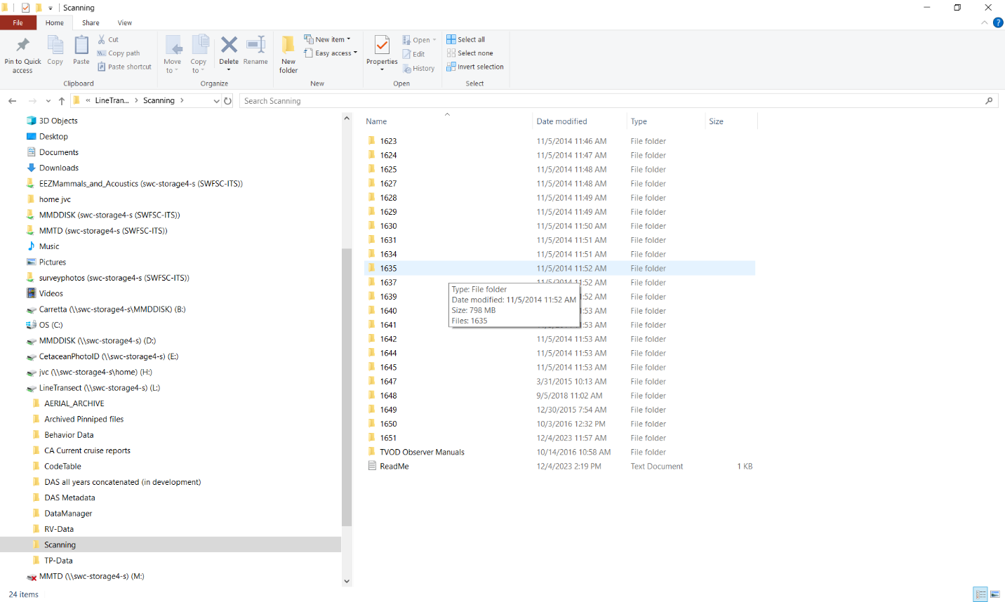

# R-utilities related to cruise data.

Also see the [Software page](https://cmap-swfsc.github.io/CMAP-SWFSC/content/Software.html) at the Github SWFSC-CMAP page, which has more details on planning new cruises and creating transects.

Several R-scripts were developed for the 2024 CalCurCEAS cruise to aid with entering group sizes into DAS files from green books (3 related scripts, appendObserverEstimates.R, misc_DAS_funcs.R, and appendGroupSizes.R, see screen grab below for directory listing). All three scripts are required to interact with a specified DAS file and a CSV file that the user creates to house the daily data for uptake into a specified DAS file. Another useful script is get_Sightings_swfscDAS.R that interacts directly with a DAS file and the R-package swfscDAS to produce a CSV file of all sighting information (see swfscDAS package vignette). There is also a script (DAS_to_JSON.R) used for converting DAS files to JSON (for plotting in CalTopo and Windy, for example).

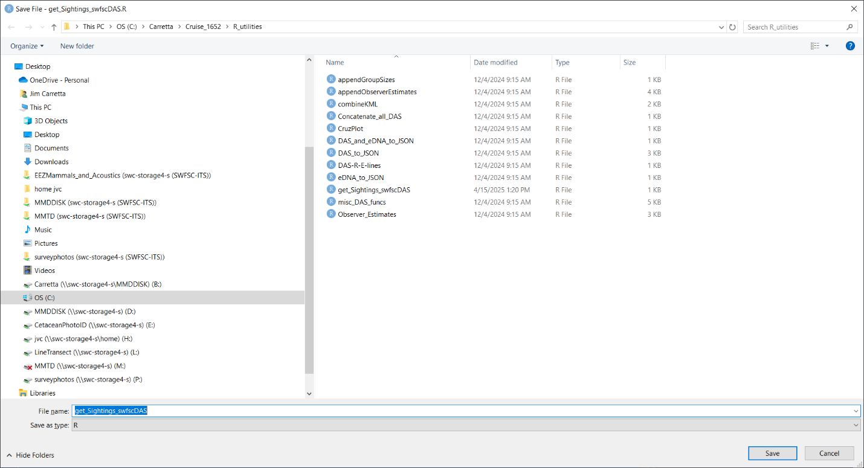

# **References**

Carretta, James V., Justin Greenman, Kristin Wilkinson, Lauren Saez, Dan Lawson, and Justin Viezbicke. 2024. Sources of human-related injury and mortality for U.S. Pacific West Coast marine mammal stock assessments, 2018-2022. U.S. Department of Commerce, NOAA Technical Memorandum NMFS-SWFSC-705. <https://doi.org/10.25923/tj6f-y570>

Carretta, J.V. and A. Henry. 2022. Risk assessment of large whale entanglements and vessel strikes from case narratives and random forest classification trees. Frontiers in Marine Science. <https://doi.org/10.3389/fmars.2022.863070>

Carretta, J.V., 2018. A machine-learning approach to assign species to ‘unidentified’entangled whales. *Endangered Species Research*, *36*, pp.89-98. https://doi.org/10.3354/esr00894

NMFS. 2023. Guidelines for Preparing Stock Assessment Reports Pursuant to the Marine Mammal Protection Act. Protected Resources Policy Directive 02-204-01. <https://www.fisheries.noaa.gov/s3/2023-05/02-204-01-Final-GAMMS-IV-Revisions-clean-1-kdr.pdf>